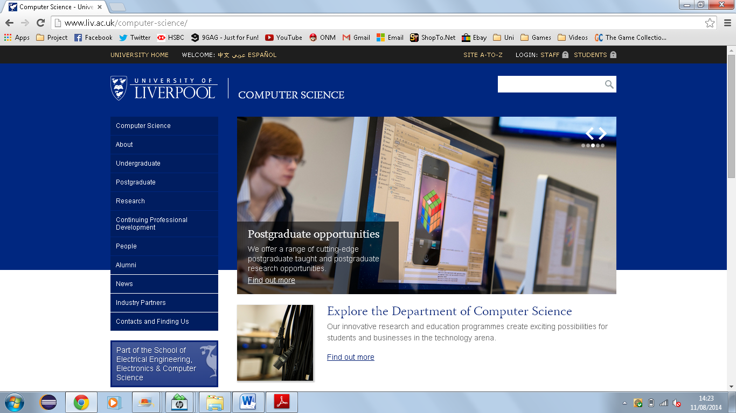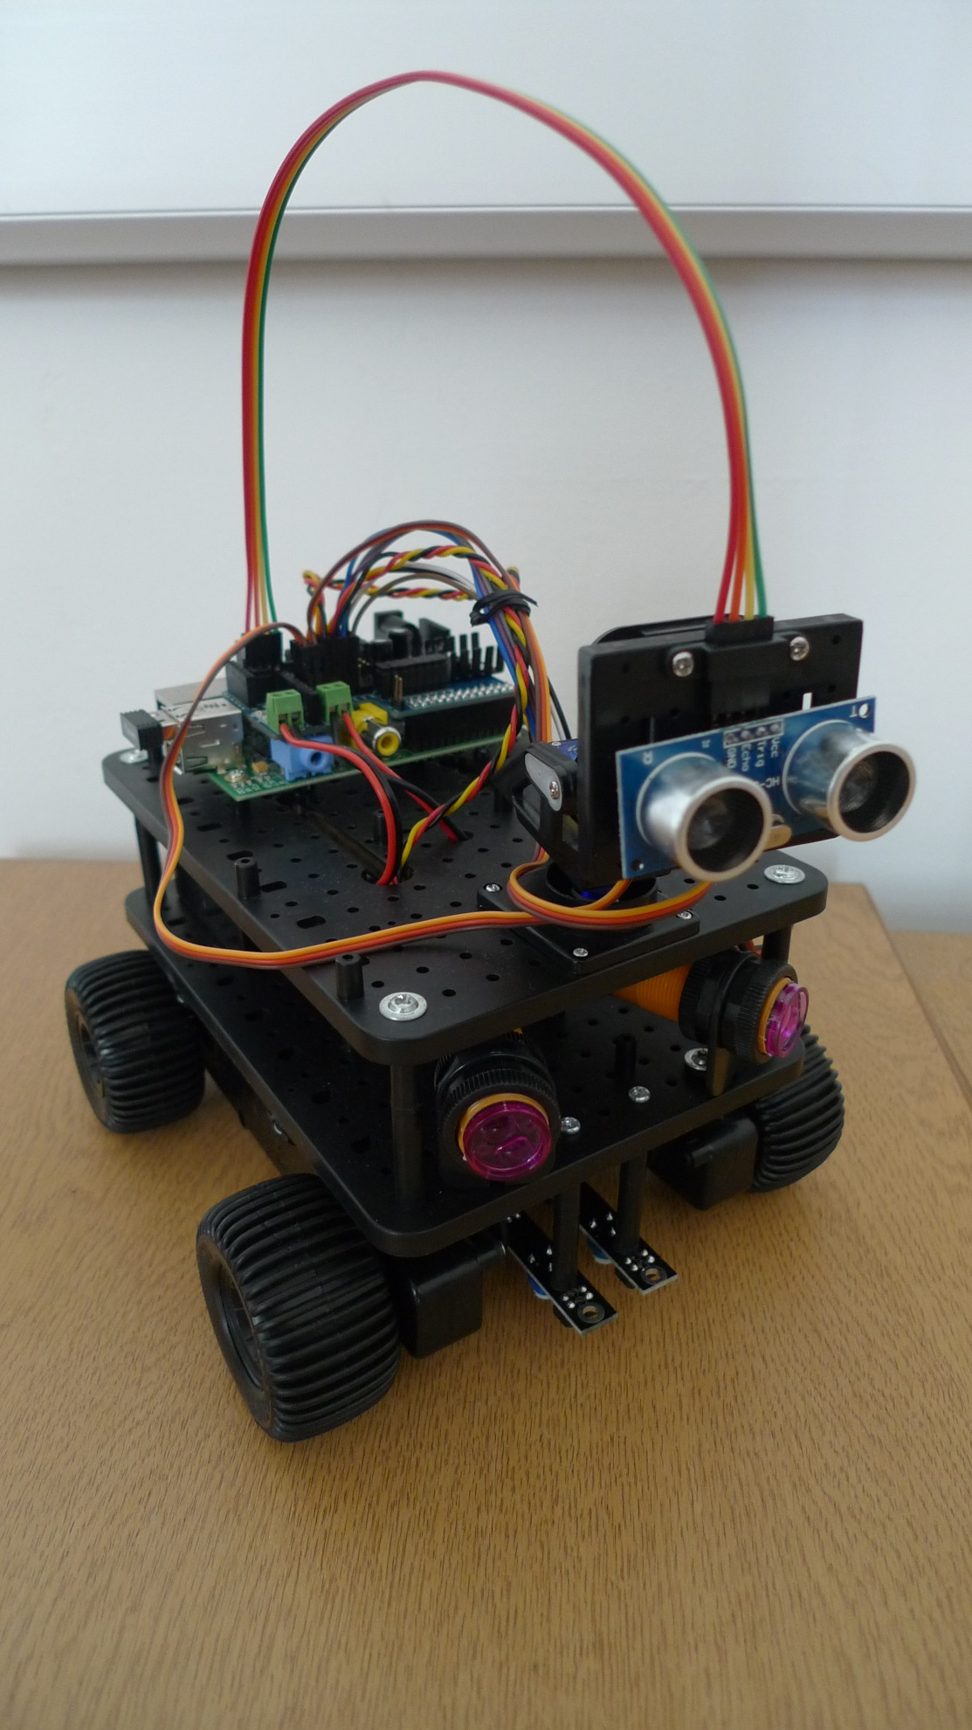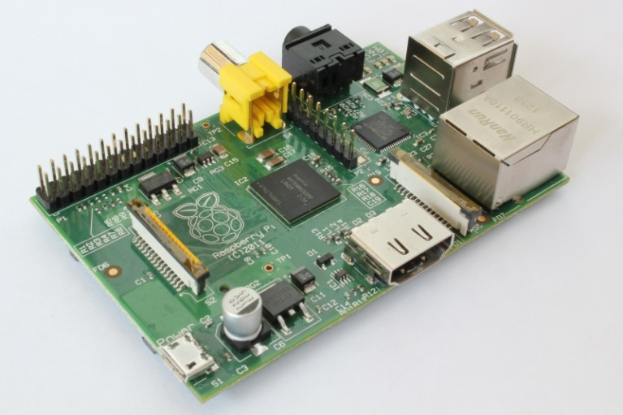

**PiRoCon Robotics Controller** This is where the power supply is plugged in. It makes it easy and safe to plug in all the sensors and it supplies the correct current and voltage to all the sensors, motors and the Raspberry Pi itself!

**Infrared Obstacle Sensors** These contain an infrared transmitter and receiver. The transmitter sends an infrared signal, and if a signal is received back by the infrared receiver, it must have been reflected off an object so the sensor is activated. When the sensor is activated there is a red light that illuminates. The robot can then be programmed to perform an action (e.g. stop or reverse) if it detects an object.

**Line Sensors** These work in a similar way to the obstacle sensors, when they are above a reflective surface they are activated and light up. This can be used to follow lines drawn on the floor!

**What is a Raspberry Pi?**

Raspberry Pi Rover

Raspberry Pi Rover

**Ultrasonic Sensor** This sends out an extremely high pitched sound then waits for it to be reflected off an object and return to the sensor. From the time taken for the sound to return, the distance to the object can be calculated.

**Raspberry Pi** This controls the robot! The SD card contains all the code to tell the motors what to do depending on the input received from the sensors

**Wi-Fi Dongle** Information is sent between the Raspberry Pi and laptop via Wi-Fi. For example the program on the laptop can send instructions to the Raspberry Pi and then the Raspberry Pi tells the motors what to do. Information can also be sent the other way, for example the Raspberry Pi can send the value from the ultrasonic sensor back to the laptop so it can be seen on the screen.

The Raspberry Pi is a small, inexpensive computer that can be connected to a monitor or TV and controlled by a mouse and keyboard plugged into it. To work, it needs to be connected to a power supply and memory card. On it, users can do everything they can do on a normal computer, such as browse the internet and play video, in addition to allowing people to explore computing and learn programming in languages such as Scratch and Python. Due to its small size it is also very versatile and can have many uses, for example as a portable multimedia player, a retro gaming machine or in this case it is used for controlling a robot!